Northlandia Public Procurement Authority
Solicitation for Commercial Items (Standard Tier)
Requirement: Batteries and Pencils
Solicitation Number: [Insert Number]
Issue Date: [Insert Date]
Response Due: [Insert Date & Time]

1. Introduction
The Authority is seeking quotations from qualified suppliers for the provision of commercial‑grade batteries and pencils. This solicitation is issued under the Authority’s standard‑tier procurement procedures, which apply to mid‑value, low‑complexity commercial purchases.
Suppliers shall submit a single quotation containing pricing, delivery information, and confirmation of compliance with the requirements set out below
2. Description of Goods
Required Items
The Authority requires the following:
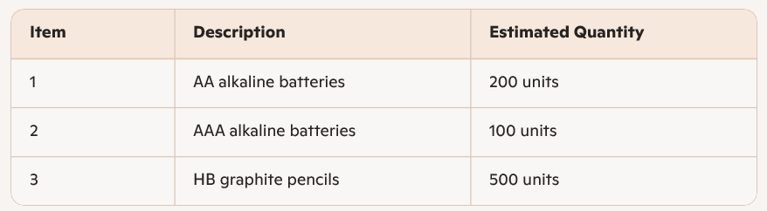
Specifications
- Batteries must be standard commercial alkaline type, suitable for office equipment.
- Pencils must be HB graphite, wood-cased, hexagonal or round, suitable for general office use.
- All items must be new, unused, and delivered in manufacturer packaging.
3. Delivery Requirements
- Delivery Location: [Insert Address]
- Delivery Deadline: Within 10 business days of award
- Delivery Terms: FOB Destination, all shipping included in price
4. Pricing
Suppliers shall provide firm, fixed pricing for all items. Pricing must include:
- Unit price
- Extended price
- Any applicable taxes or fees
- Delivery costs
Partial quotations are not accepted.
5. Evaluation Criteria
Award will be made to the supplier offering the best value, considering:
- Total evaluated price
- Ability to meet delivery timeframe
- Compliance with specifications
- Past performance or demonstrated reliability (if available)
This is a best-value, price-driven evaluation, not a complex technical evaluation.
6. Terms & Conditions (Standard Tier)
Performance Standard
The Supplier shall perform in accordance with standard commercial practices and the requirements of this solicitation.
Acceptance
Items are subject to inspection and acceptance by the Authority.
Payment Terms
Payment will be made within 30 days of receipt of a valid invoice.
Intellectual Property
No IP is expected to be created under this procurement.
Confidentiality
The Supplier shall protect any non-public information received from the Authority.
Termination
The Authority may terminate the solicitation or any resulting contract for convenience with written notice.
7. Submission Instructions
Suppliers shall submit quotations electronically to:
Email: [Insert Email]
Subject Line: “Quotation – Batteries and Pencils – [Supplier Name]”
Quotations must be received by the due date and time listed above.

